Contents

Step- 1 1

Step-2 1

Step-3 1

Step-5 1

Step-6 1

Step-7 1

Step-8 2

Step-9 2

Step-10 5

Step-11 5

## Step- 1

Create a directory .

For ex: D:\mygithub\nimpractice>mkdir firstdemo

## Step-2

cd firstdemo

## Step-3

At command prompt > nimble init

And accept all the default values

## Step-5

Navigate to the directory and run the nimble build with debug flag

Ex:

D:\mygithub\nimpractice\firstdemo>nimble build --debugger:native

## Step-6

It will create the create the following files as shown in the below screenshot

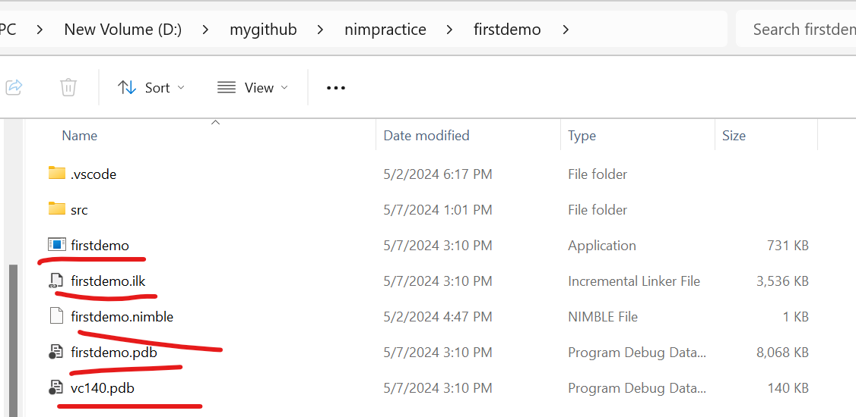

## Step-7

In Visual Studio Code search and install nim extension

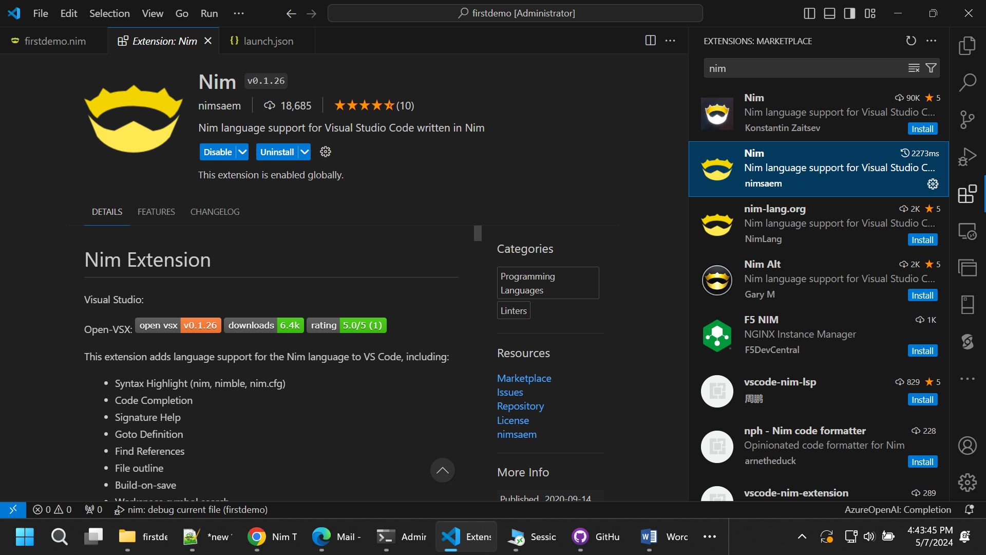

## Step-8

In Visual Studio Code search and install lldb extension

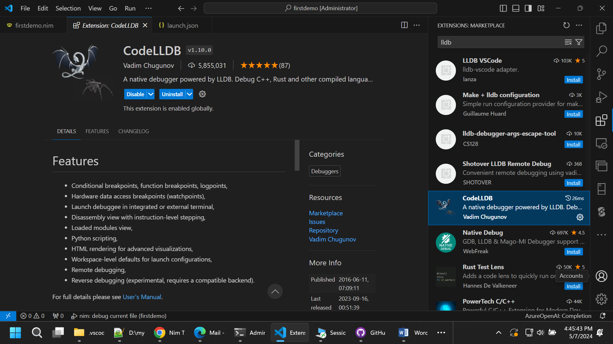

## Step-9

In VS Code create files launch.json and tasks.json under .vscode folder

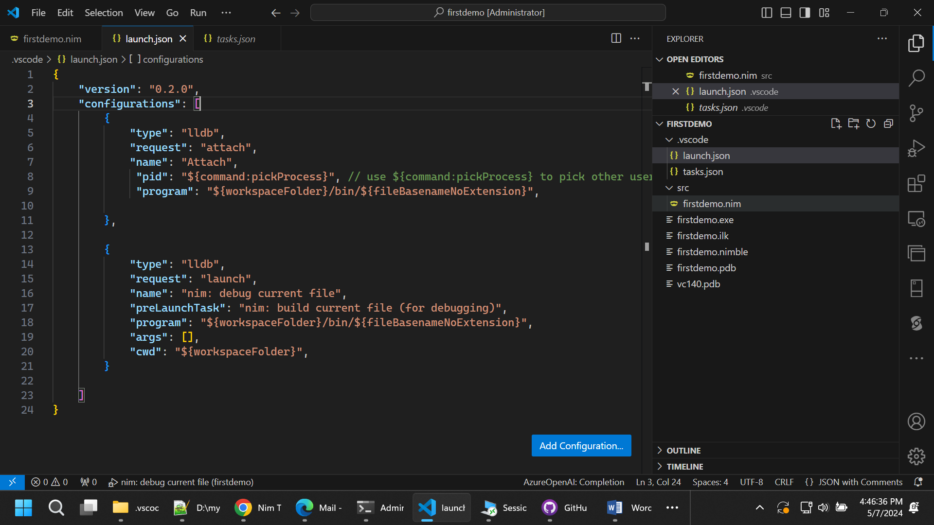

**Below are the sample launch.json**

{

"version": "0.2.0",

"configurations": [

{

"type": "lldb",

"request": "attach",

"name": "Attach",

"pid": "${command:pickProcess}", // use ${command:pickProcess} to pick other users' processes

"program": "${workspaceFolder}/bin/${fileBasenameNoExtension}",

},

{

"type": "lldb",

"request": "launch",

"name": "nim: debug current file",

"preLaunchTask": "nim: build current file (for debugging)",

"program": "${workspaceFolder}/bin/${fileBasenameNoExtension}",

"args": [],

"cwd": "${workspaceFolder}",

}

]

}

**Below are the sample tasks.json**

// .vscode/tasks.json

{

"version": "2.0.0",

"tasks": [

{

"label": "nim: build current file (for debugging)",

"command": "nim",

"args": [

"compile",

"-g",

"--debugger:native",

"-o:${workspaceRoot}/bin/${fileBasenameNoExtension}",

"${relativeFile}"

],

"options": {

"cwd": "${workspaceRoot}"

},

"type": "shell",

}

]

}

## Step-10

Navigate to the directory D:\mygithub\nimpractice\firstdemo

You will find firstdemo.exe

Run the exe and get/note the processeid

## Step-11

In VS code Ctrl+Shift+P and LLDB:attah to process

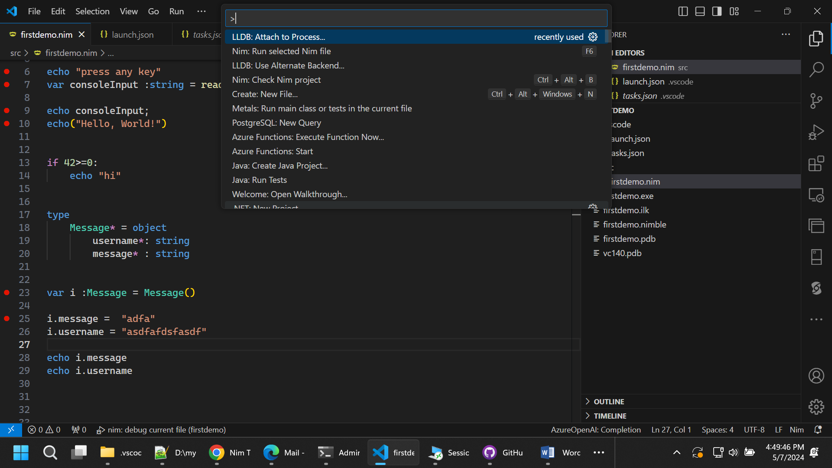

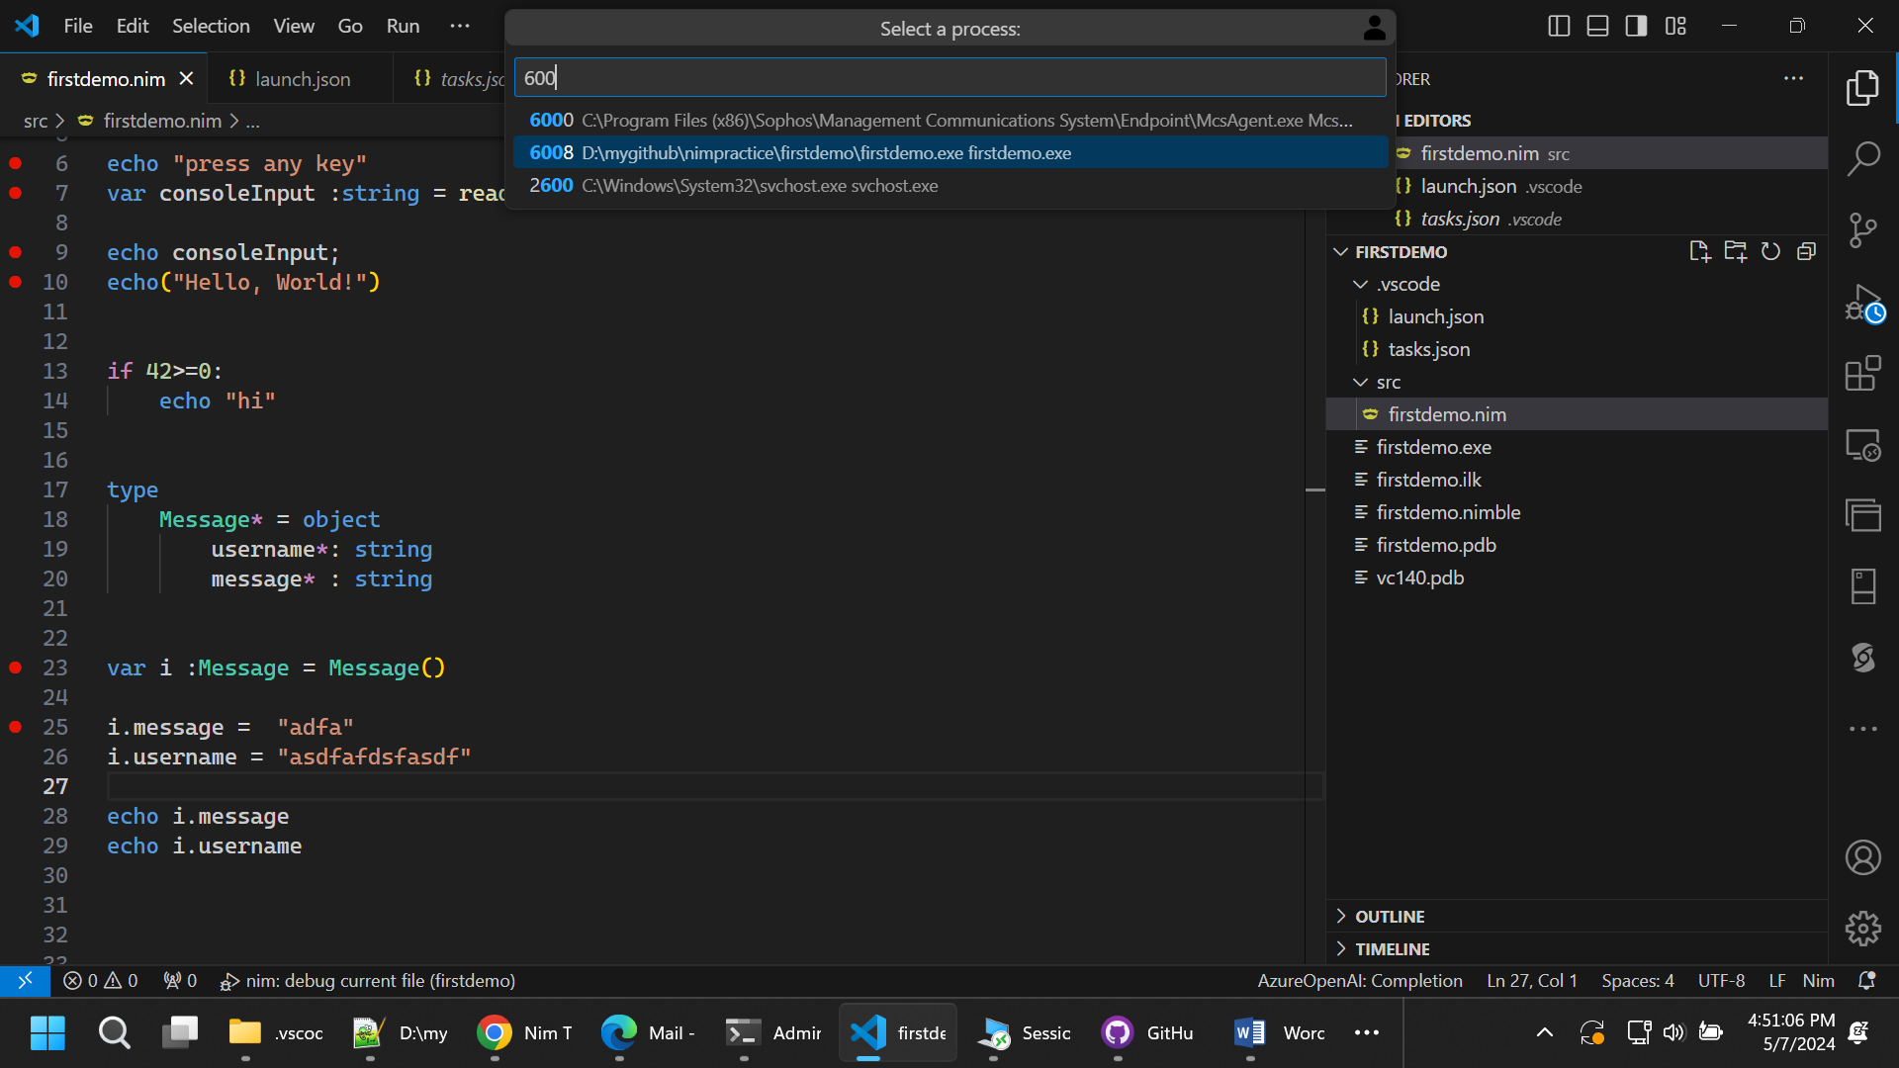

Put the break points some where in code and you will see breakpoints will hit.